*Nhóm 2 – Đề tài game AngryBirds*

**TÀI LIỆU CHUẨN MÃ NGUỒN**

Hướng dẫn setup Checkstyles

1. Update site for the Eclipse Checkstyle Plugin.
   1. <http://eclipse-cs.sourceforge.net/update>
2. Window -> Preferences -> Checkstyle. Press the "Set as Default" after selecting the right entry.

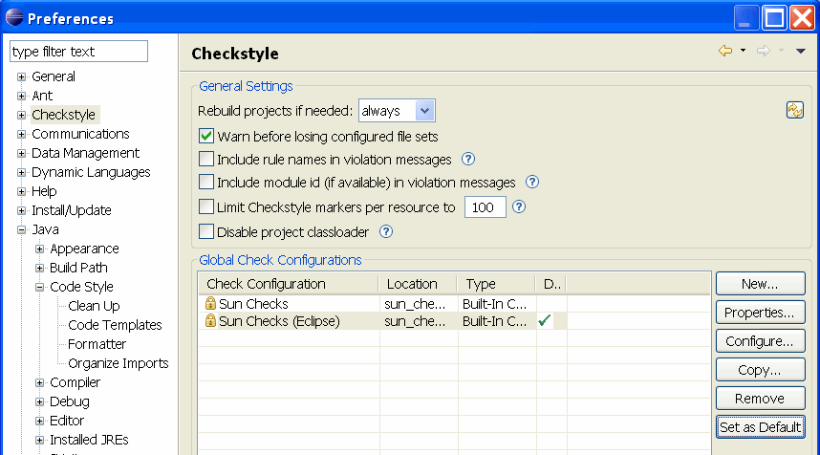

1. Using Checkstyle in your projects

